Operation Manual:

Pretty Girl
Beneteau 39’

Welcome Note

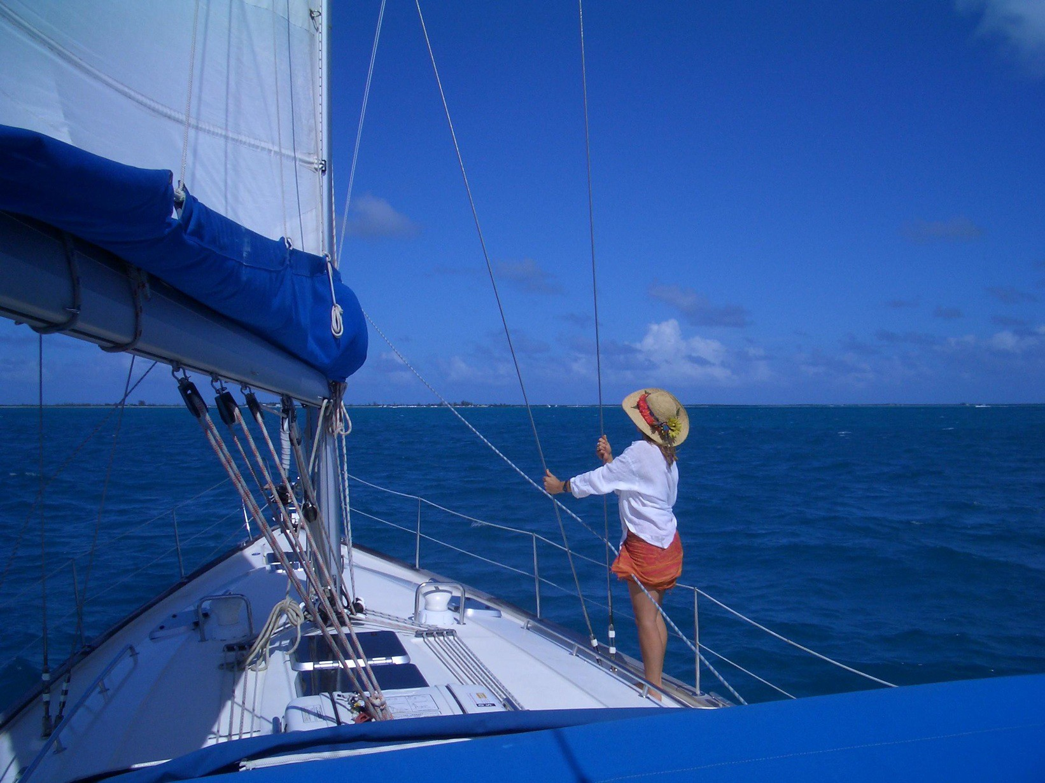

Hello and welcome to New England Sailing Center and your Beneteau 39 “ Pretty Girl”. Inside this manual you should find directions and instruction for everything you will need to know in order to operate you vessel safely and efficiently.

Please take the time to read through this manual before you head out and feel free to ask any of our staff questions about the boat or manual. Here at NESC we want you to have the most comfortable and safe experience as possible.

We hope you have a great trip and enjoy these beautiful cruising grounds. Should you have any problems while aboard please don’t hesitate to contact us.

Kind regards and fair winds, The NESC staff

Office number – (401) 619- 1697 {Mon – Sun, 9-6} Emergency number and after hours (401) 592-0386

Table of Contents
Yacht Specs 4
Boat Equipment 4
Safety 6
Life Saving Signals 7
Heads 10
Showers 11
Electrical Panel 12
Batteries 13
Bilge Pumps 15
Refrigeration 16
Mechanical 17
Propane and Stove 18
Fresh Water System 18
Instruments 19
Equipment 21
Maneuvers 23
Reefing Guidelines 25
Troubleshooting 25

Yacht Specs

Boat Specifications
Max Passengers | 8
Cabins | 3 + convertible settee
Heads | 2
Showers | 3
L.O.A. | 39'
L.W.L. | 38'4'
Beam | 12'9"
Draft | 5', 9"
Engine | Yanmar
Fuel | 58 Gallons
Water | 85 Gallons

Boat Equipment
Deck Equipment
- Cockpit table with ice-­‐box
- Cockpit shower
- Cockpit cushions
- Electric anchor windlass
- 2 x Steering wheels
- Dinghy
- Outboard motor
- Bimini

Electronics / Facilities
- VHF
- Speedometer
- Depth sounder
- Wind instruments
- Radio, CD player, and iPod connection
- GPS and chart plotter
- Cockpit speakers
- Autopilot
- Electric fridge
- Outlet 12 V plug

Rigging / Sails
- Roller furling genoa
- Battened main sail

What's included in your charter
- Linens and towels
- Fully equipped galley
- Water heater
- BBQ grill
- Navigation charts and manual navigation tools
- First aid kit, life preservers and emergency equipment
- Starter kit: Dish soap, toilet paper, 1 roll paper towels, trash bags, 409, Cruzan Rum and Coke, spice kit

Safety
All of the NESC boats undergo regular safety checks and strictly adhere to USCG Safety Requirements.

  - Your Life-­‐Jackets are located in the Cabin Table Settee

  - Please see instructions on life raft for operation, do not pull cord until life raft is free from obstructions and the boat, then it is ready to inflate. The life raft will do so automatically.

  - First Aid Kit and Flare Box are located under the seat at navigation station

  - Your safety equipment is located in the Starboard Cockpit Locker.
-­‐ Thermal Protective Blanket
-­‐ Jump Lead
-­‐ Emergency VHF Antennae
-­‐ Second Anchor

-­‐ For Emergency Radio Operations see yellow warning sticker procedure

-­‐ Fire Safety Equipment Location
- Fire buckets in Starboard cockpit locker
- Fire blanket in galley
- Fire extinguishers beneath Nav table and in both aft cabins

-­‐ Engine controls – Refer to boat operations manual for operation instruction

-­‐ If you experience bad weather we recommend you navigate to a near-­‐by port of refuge by referring to charts and cruising guide. If in need of advice or assistance call NESC Office 401 619-1697.

Life Saving Signals

Fire Safety

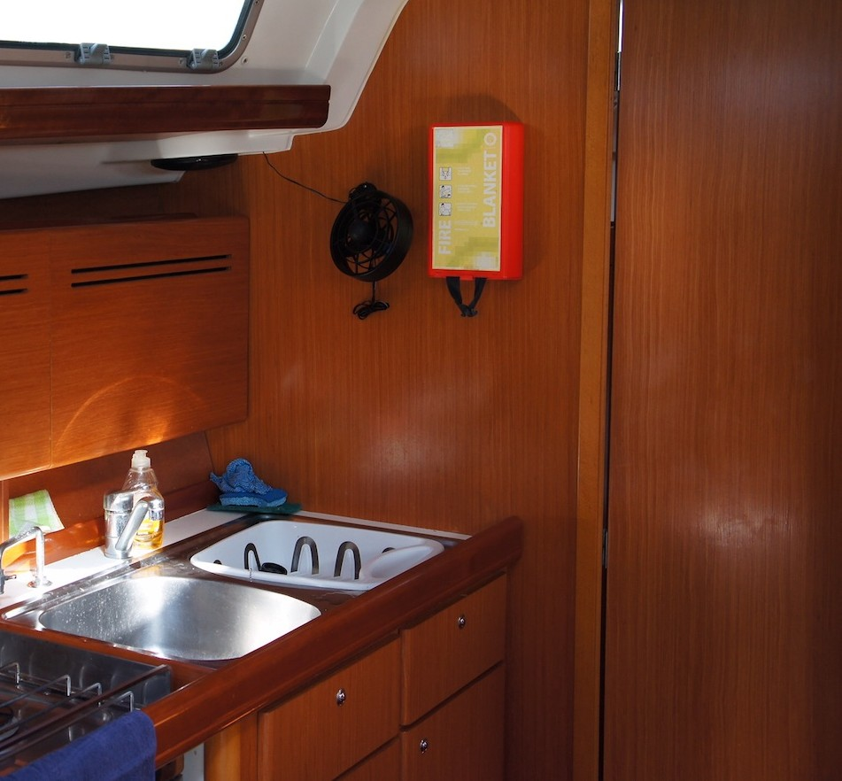
Your fire blanket is located above the galley sink for use In the event of a stove/pan fire.
- Pull down hard on black straps
- Place blanket over fire and smother flames
- Let it sit over pan for extended time, even if the fire appears to be extinguished, exposing hot stove or pan to oxygen could result in reignition

3 fire extinguishers are located on your vessel. Located on the side of your navigation station and one located in each aft cabin.

When using fire extinguishers follow the P.A.S.S rule
- Pull the pin
- Aim at the base of the fire
- Squeeze the handle
- Spray/spread along the base of the fire

Navigation seat fire extinguisher

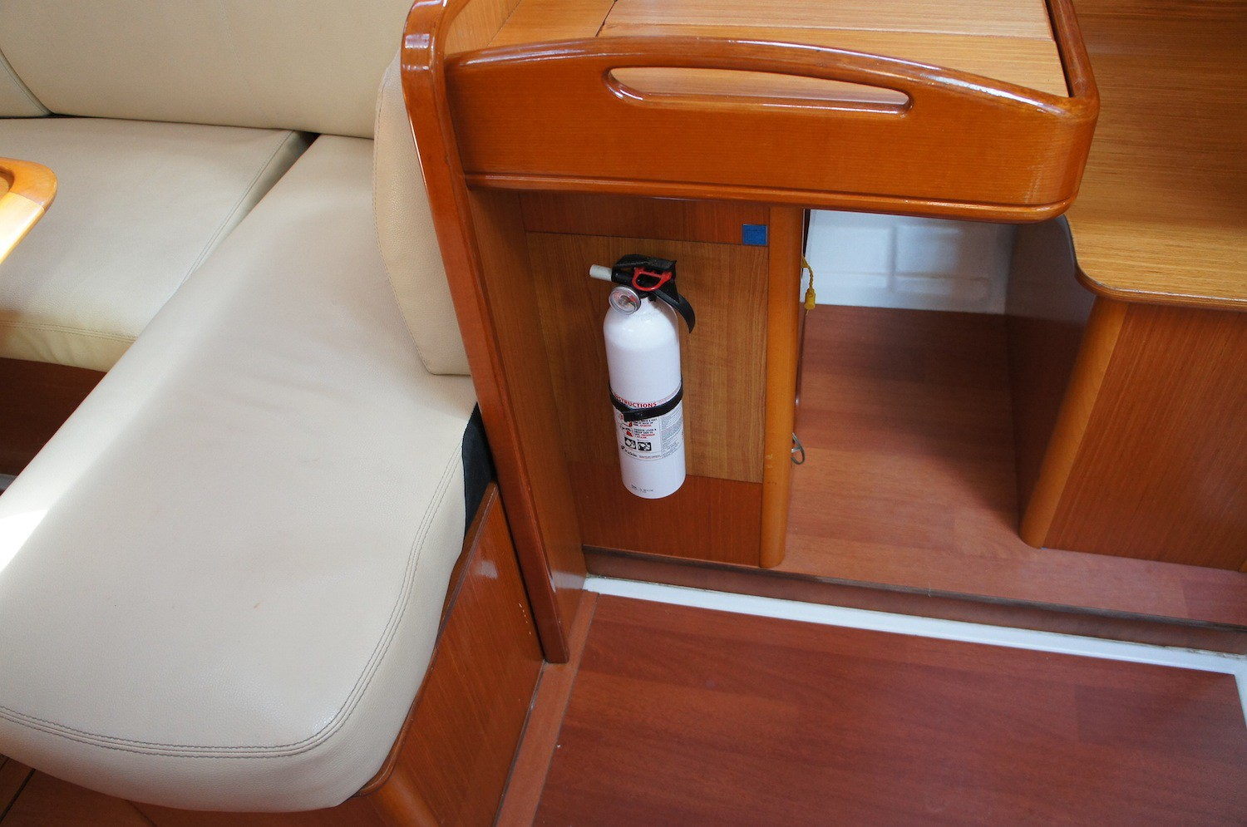

Port cabin fire extinguisher
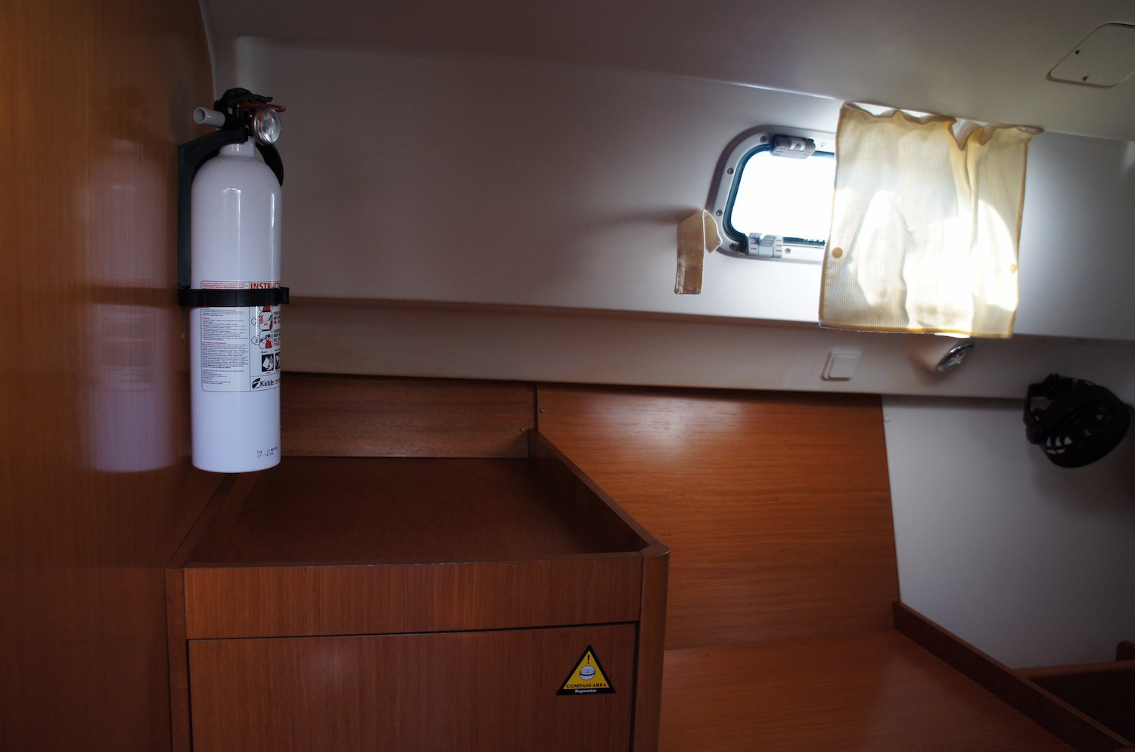

Starboard cabin fire extinguisher
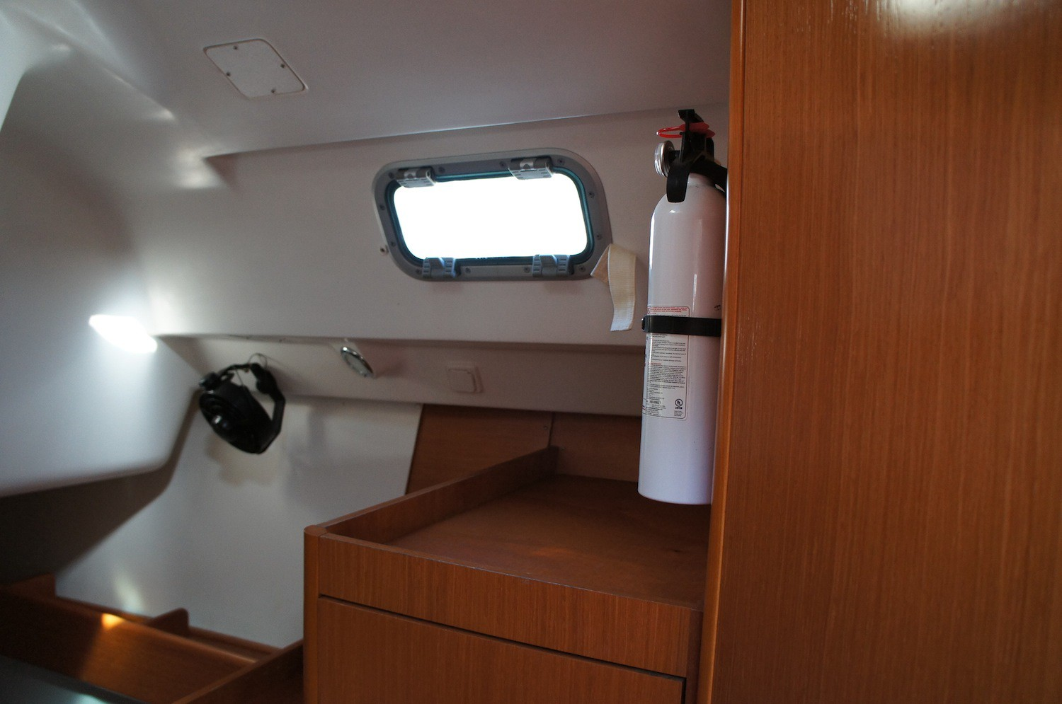

In the event of an engine fire, your companionway stairs is fitted with a small plastic hatch through which you should extinguish a fire through, rather than lifting the stairs thus feeding the fire additional oxygen.
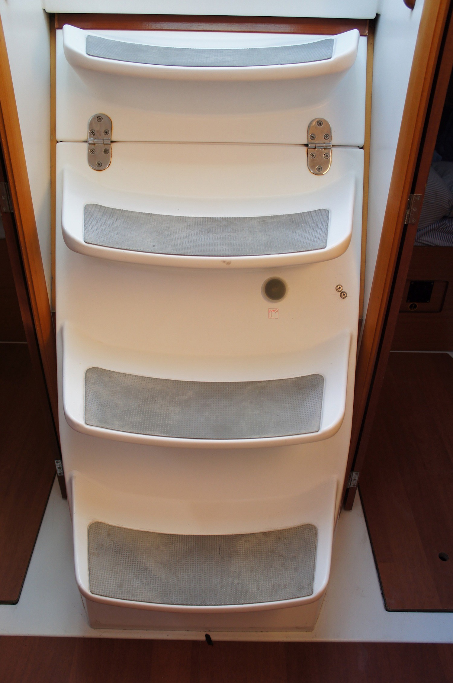

Heads

Usage

It is very important for your comfort and hygienic safety onboard that you use heads according to the following procedures.

- Prime the head ensuring there is some water in the bowl.
- Use the head ensuring nothing goes into the head other that what you have digested and a very minimal amount of paper.
- To clear the head pump 20 times ensuring the water in the bowl becomes clear.
- Change the flush setting to dry and pump out any water leaving the head dry for the next person.
- Whenever at the dock be sure to use shoreside facilities so as to keep our marinas and anchorages clean.

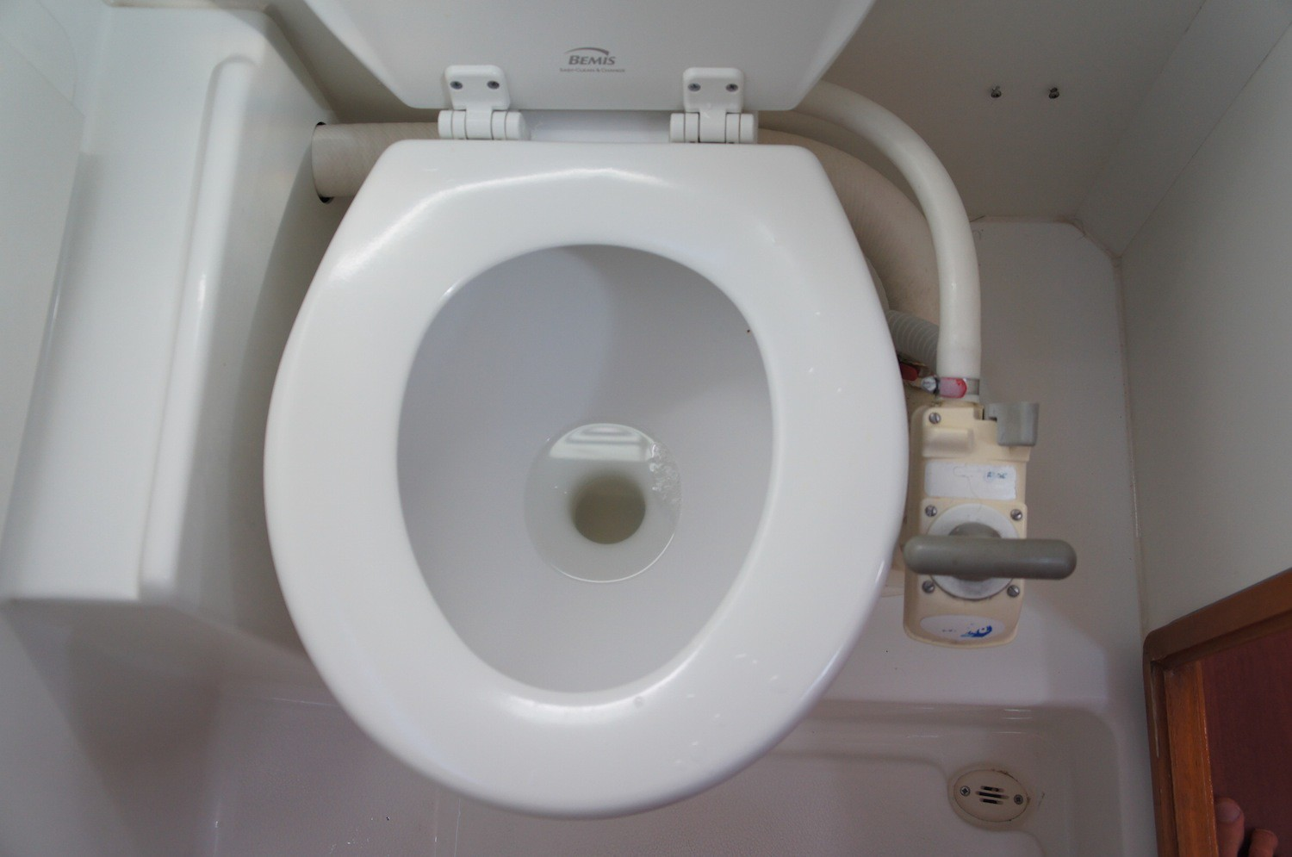

Showers

Each of the heads are equipped with a shower. In addition the transom has a shower hose with fresh water access.

Usage

- First, ensure that the fresh water pump breaker is turned to the on position at the 12v panel.
- The shower drain breaker should also be turned on at the 12v panel.
- For your comfort please drain the shower pan after each use with the small black button beside the sink.
- The cockpit/transom shower can be fully controlled from the unit with the
- flow control switch on the shower head.
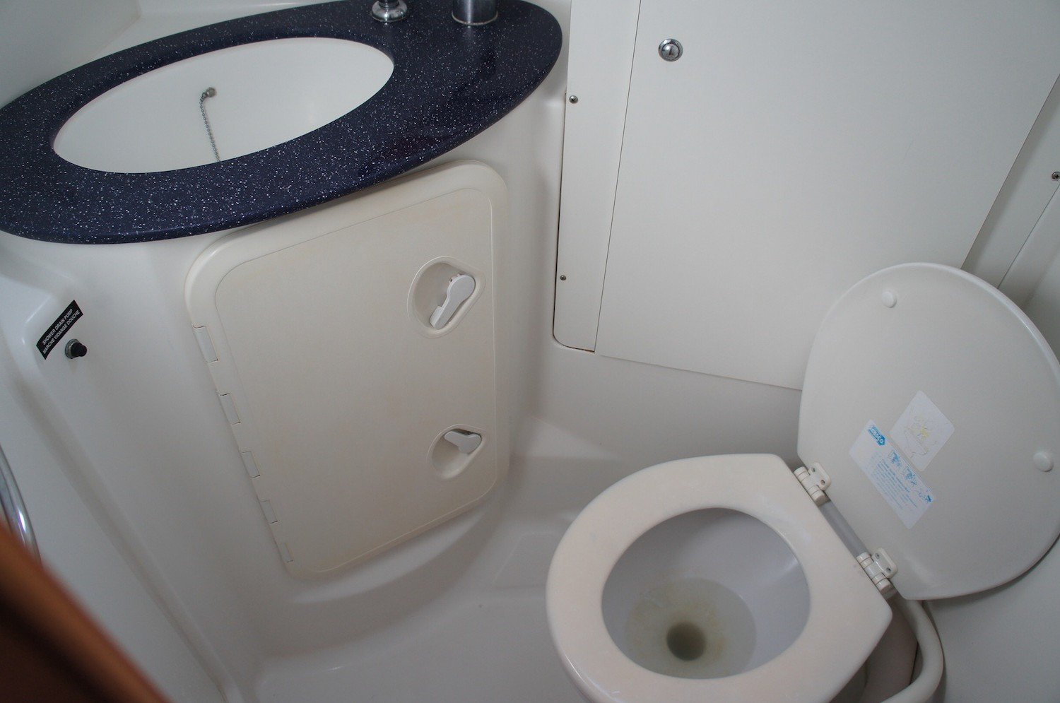

Electrical Panel

12 Volt Panel

First column | Second Column | Third Column | Fourth Column
Navigation | Water Pressure | Refrigerator Unit | Meter for Volts, Water, Fuel
VHF/HIFI | Bilge Pump | Fans
Auto Pilot | Shower Pumps | Cockpit Light
Gas Solenoid | Navigation Lights | Deck Light
 | Mooring Lights | Cabin Lights | 12 Volt Plug
 | Steaming Lights | Comfort/ 12V DC out

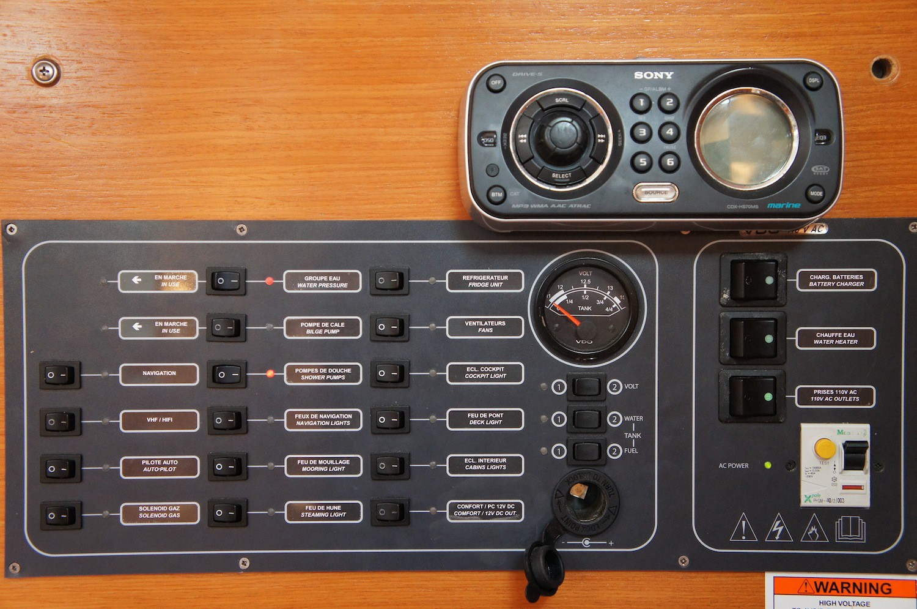
110 Volt Panel
- Battery charger
- Water heater
- 110AC Outlets
- Shore power breaker

Batteries

Your yacht is not equipped with a generator. Therefore anytime you use electricity on the boat you will need to charge you batteries to replenish energy used.
Our engineers suggest that you charge the batteries for 3-­‐4 hours daily, usually two hours in the morning and two hours in the evening works well.

 Start your engine according to manual starting procedures.
 Hold in the red button on the center of the throttle lever.
 Increase RPM to 1500 (engine not in gear) in order to charge efficiently.

Battery switches and windlass breaker
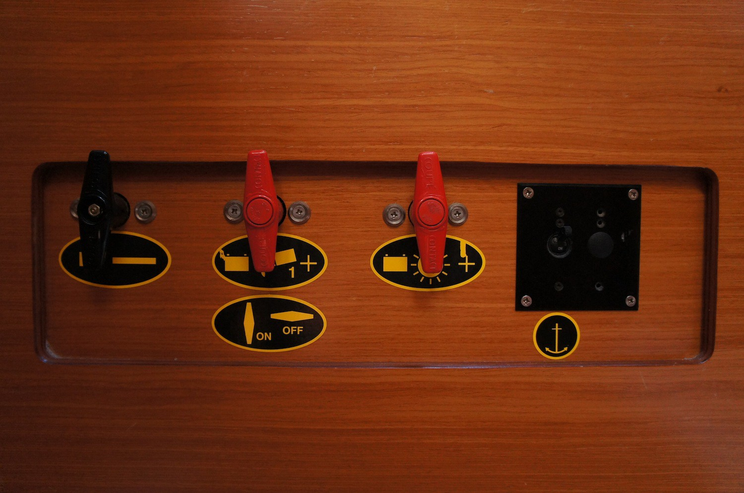
- Battery switches (Aft port cabin)
- Windlass breaker switch

Your inverter converts DC power into AC power.
 Plug the connection into the 12DC outlet on your electrical panel
 Switch on the 12DC switch
 Turn on the inverter
 Plug in your device and charge
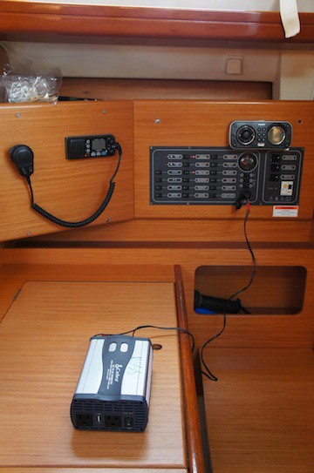

Bilge Pumps
 Your boat is equipped with an automatic bilge pump. It is wired directly to your batteries and cannot be switched off from your electrical panel. When it is in use a green led will light up on the 12v panel. You can also force the bilge pump on from the bilge pump breaker if your float switch fails.
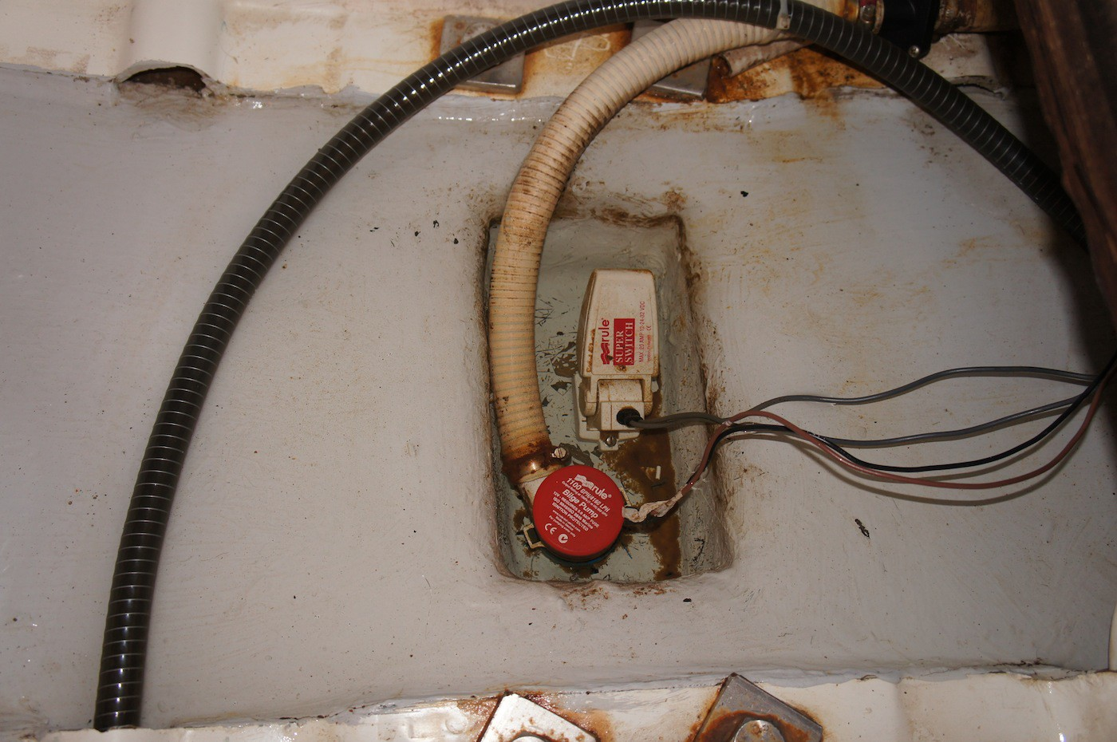

 You also have a manual bilge pump which can be operated from behind the port side steering wheel.
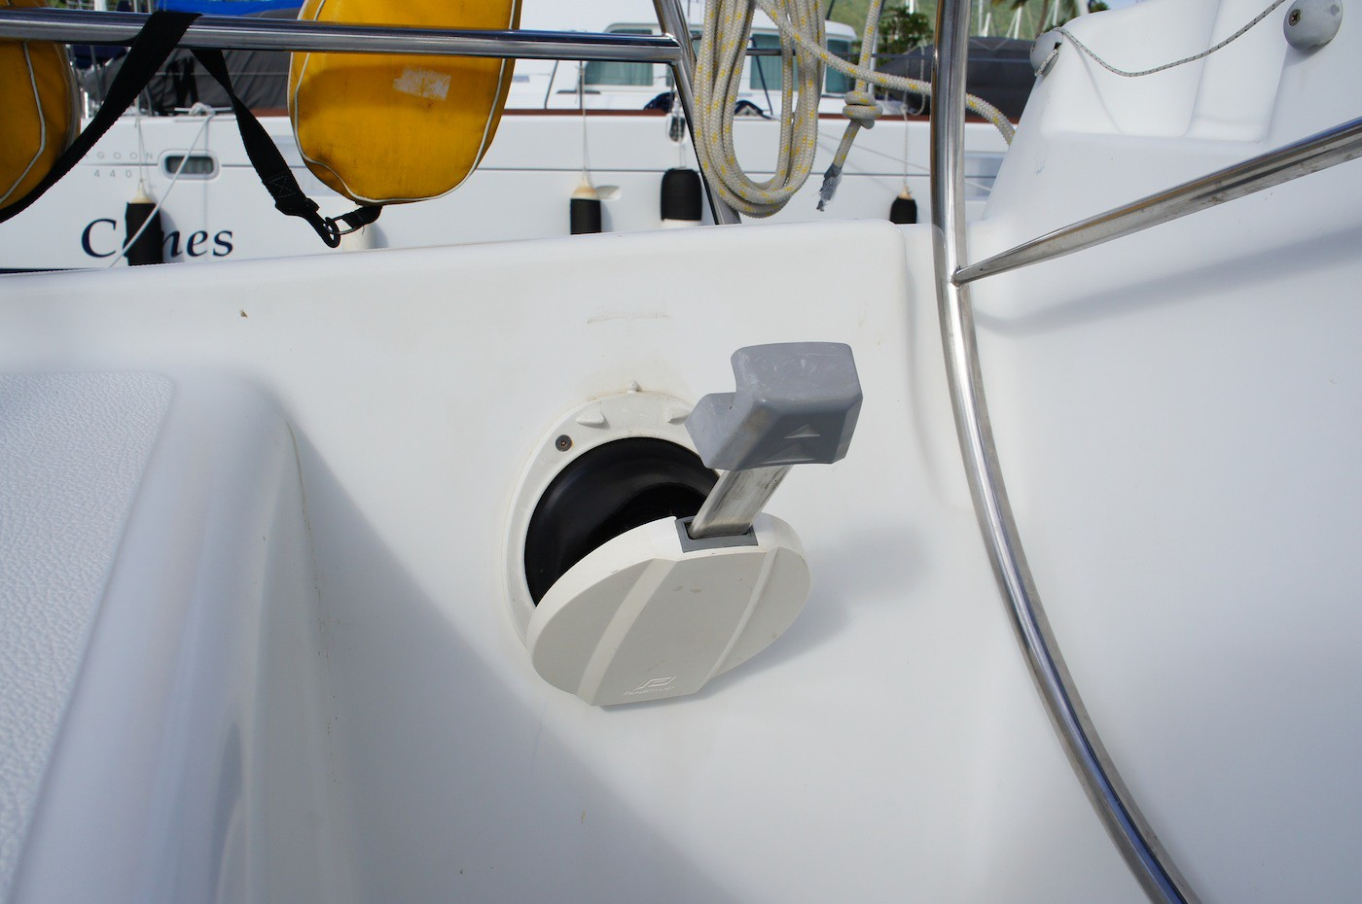

Refrigeration
Your yacht is equipped with one large refrigerator. In order to ensure proper refrigeration please follow these guidelines:

 Supplement your refrigerator with a block of ice and a bag of ice cubes at the start of your charter.
 Pack the fridge in the reverse order of which you think you will use your food.
 When opening the fridge try to take out everything you will need for that meal at the same time.
 Use the drain button to empty any melted ice daily.

If you follow these steps not only will your food stay better refrigerated but your batteries will do less work to keep the refrigerator cool.
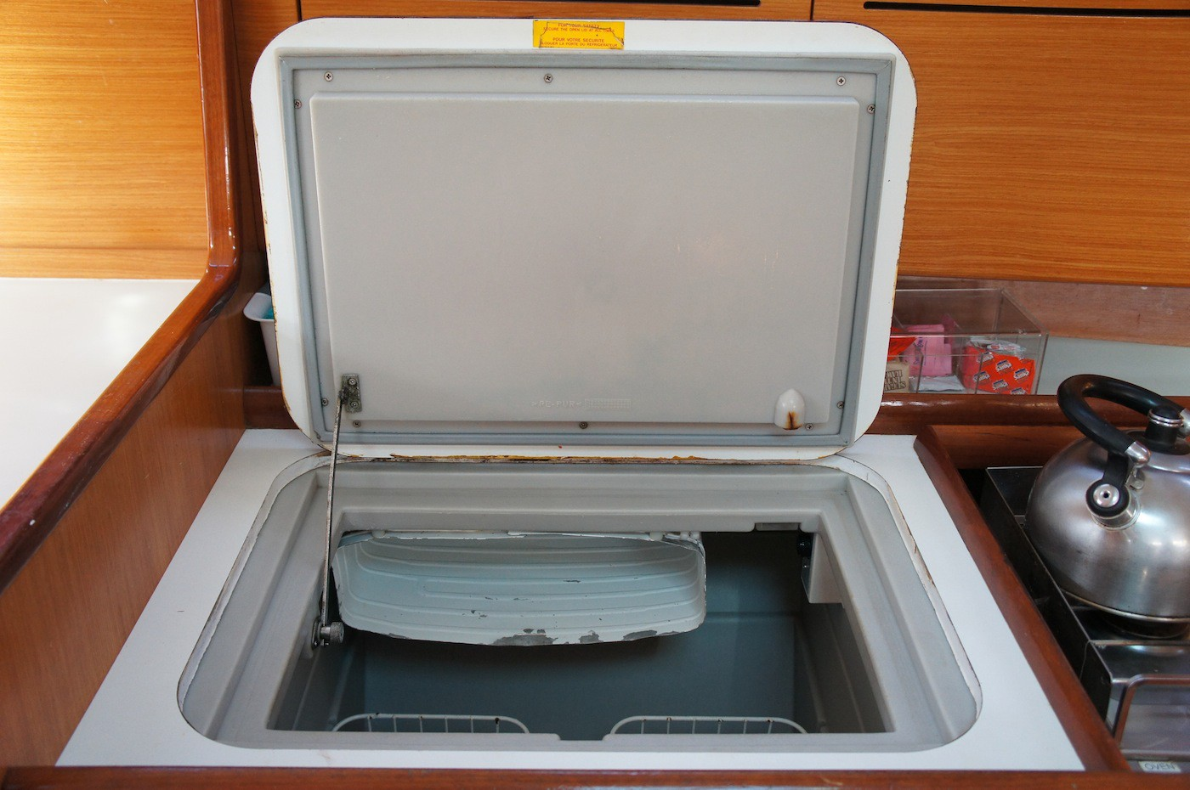

Mechanical

Engine start procedure
- Ensure throttle is in neutral position
- Turn key one click clockwise until alarm sounds
- Turn key another click clockwise until engine starts
- Ensure water is coming out of the exhaust

To stop the engine
- Ensure throttle is in neutral position
- Push stop button until engine stops, DO NOT turn the key to off position until engine is stopped.
- An alarm will sound
- Turn key counterclockwise to upright position as in the photo below
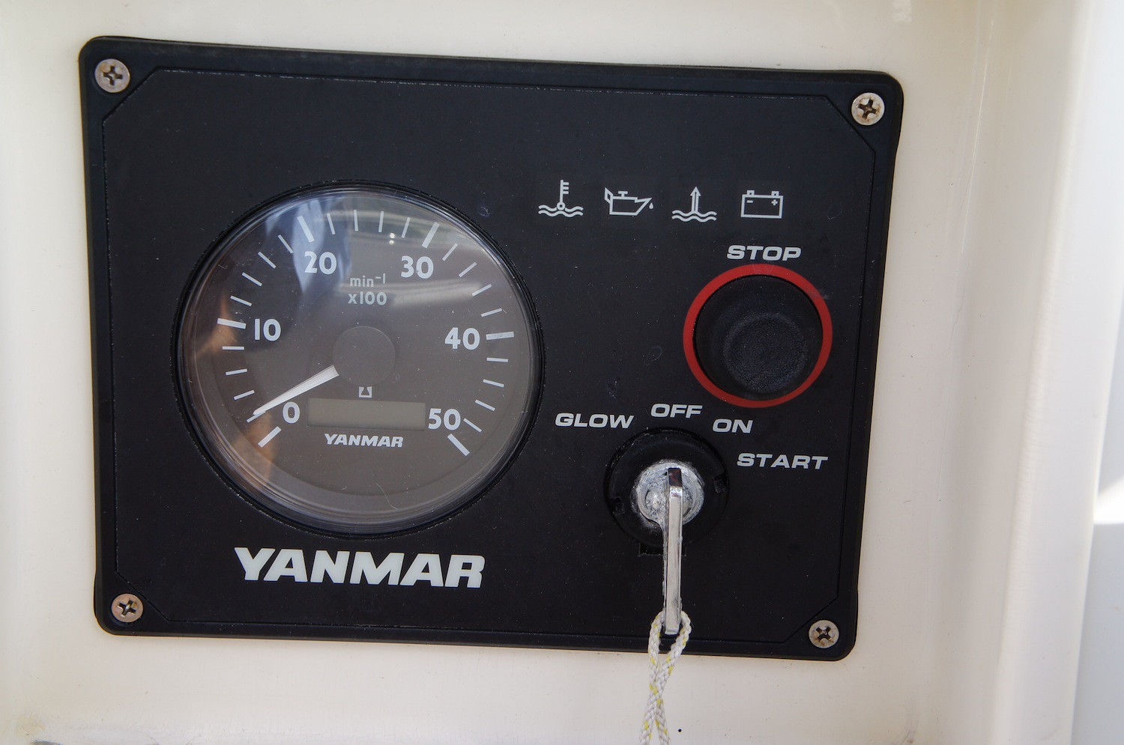

Daily Engine checks
- Check belt for damage and ensure it is tight (should turn no more than 90 degrees)
- Check oil level. Dipstick is located on the left hand side of the engine. The level should be at least halfway between the two level marks. If not, use spare oil located in your navigations table’s seat. To add oil open orange fill cap on top of engine. Be careful not to overfill.
- Check coolant level. If low please top up. Spare coolant is also located in navigation seat

At the first sig of engine trouble please call NESC for assistance.

Propane and Stove
The propane locker is located on the port side of the transom.

Do not change propane tank when BBQ is lit.
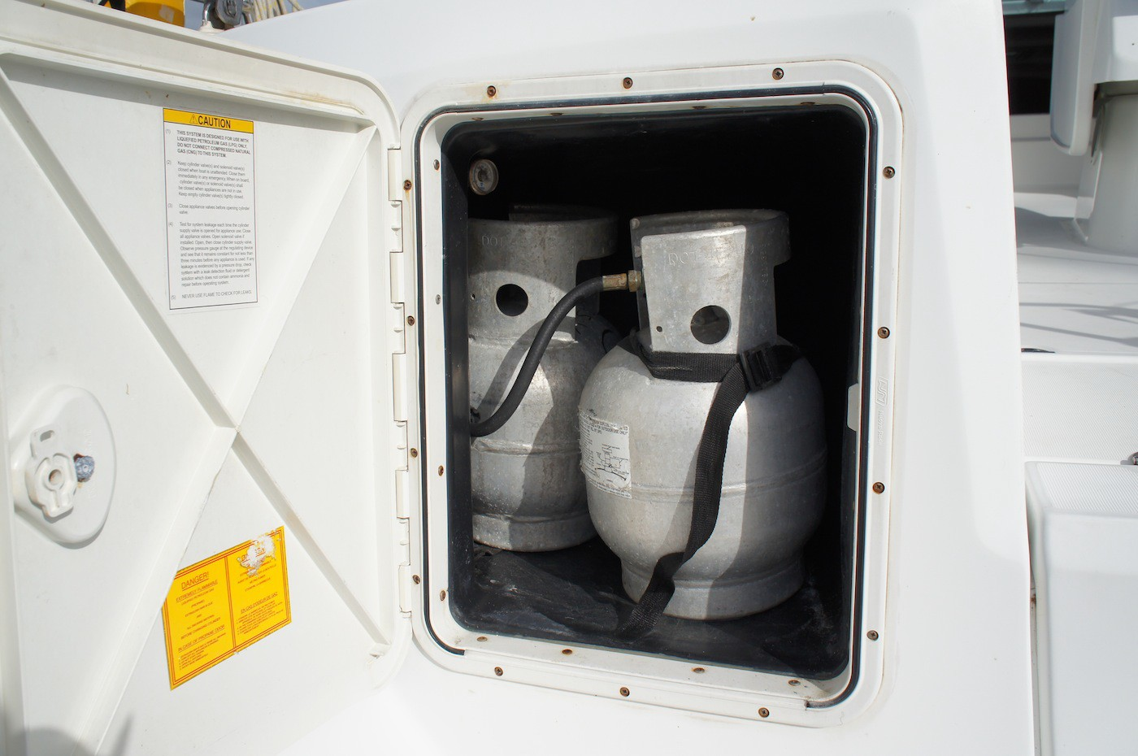

Usage
- Turn on the gas solenoid switch on your instrument panel. There is also a second solenoid switch located on the right hand side of the stove, this should be in the up position.
- Light your match, then push in the stove’s knob and turn 90 degrees counterclockwise.
- Light the burner and hold down knob for 15 seconds to ensure the whole burner is ignited
- To turn of the stove, turn off one of the solenoid switches. After solenoid has been switched off allow remaining gas in lines to completely burn off. After the burner has gone out return the stove knob to the off position and turn off the second solenoid switch.

If you suspect a gas leak do not use any of the electrical systems on board including the bilge pump.

Fresh Water System

- Serenity has one water tank with a capacity of 85 gallons. Try to conserve your water usage or expect to refill at some point during your charter

Instruments
VHF
- Ensure radio is switched on and at a high volume.
- Ensure that it is set on the hi setting unless you are calling a vessel that is very near.
- Turn squelch up until you hear a hissing noise and then down just enough for it to stop.
- Select channel for calling.
- Hold down switch on handset while talking and release when not.
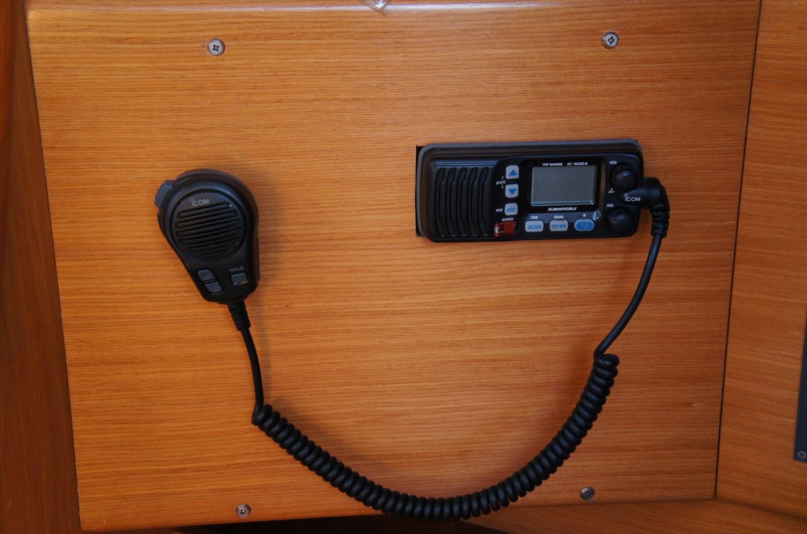

Useful channels

16 – For hailing another vessel and distress calls only 68 – Marinas and Yacht Clubs – for reservations etc. 06/09 – Non commercial ship to ship
05 --weather

In the event that you are involved in an incident that is not life threatening please contact the NESC office immediately on 401 619-1697. Please report as much information possible so that we can best assist you.

Your yacht is also equipped with the following:

 Raymarine ST6002 Autopilot
 Raymarine ST60+ Tridata
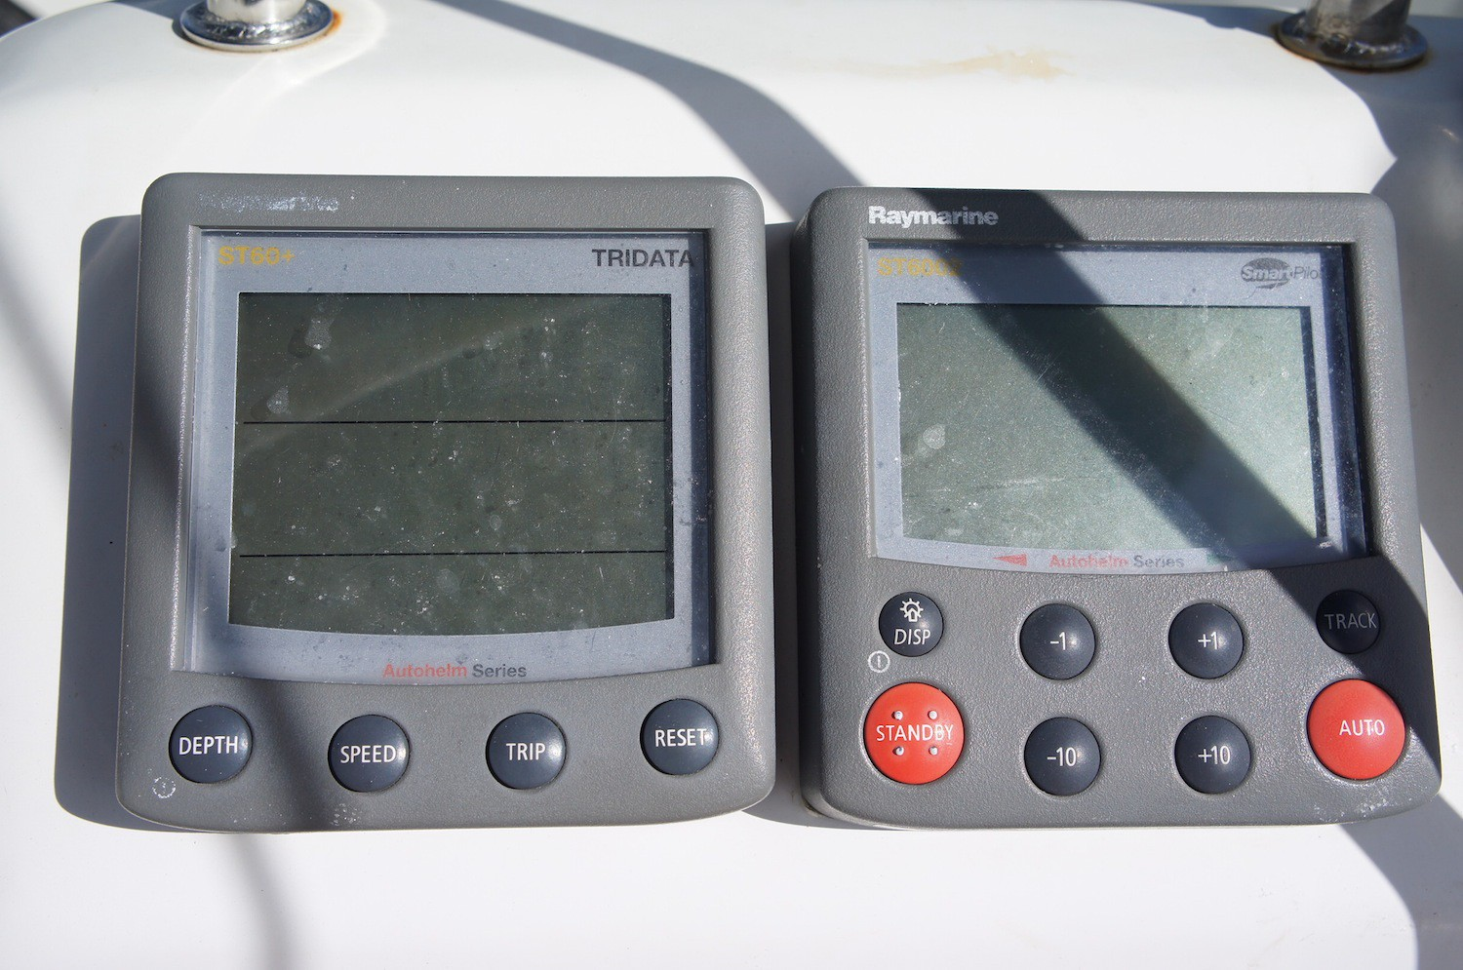

 Raymarine e series chartplotter
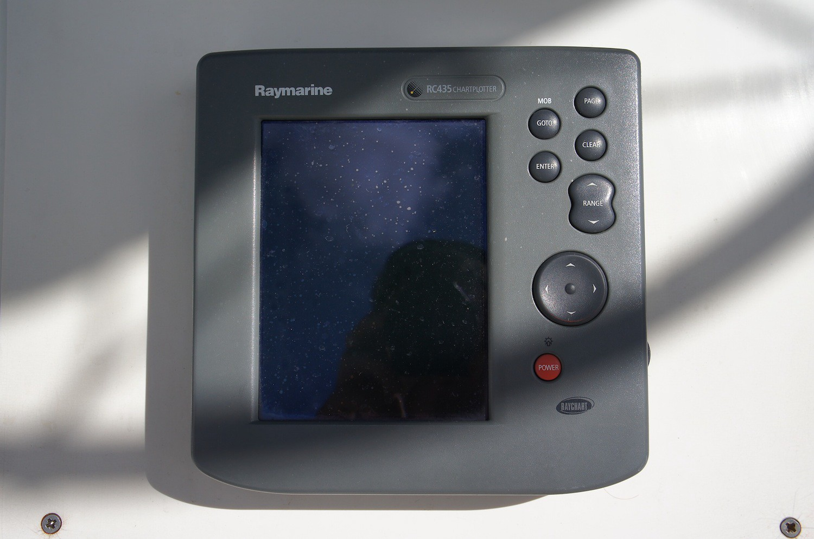

Equipment

BBQ
- Before lighting your BBQ ensure your dinghy is tied upwind on the bow of your boat
- Never use the BBQ while sailing or on dock
- Never change propane tanks while using the BBQ
- Light your charcoals on the windward side of the BBQ for best results
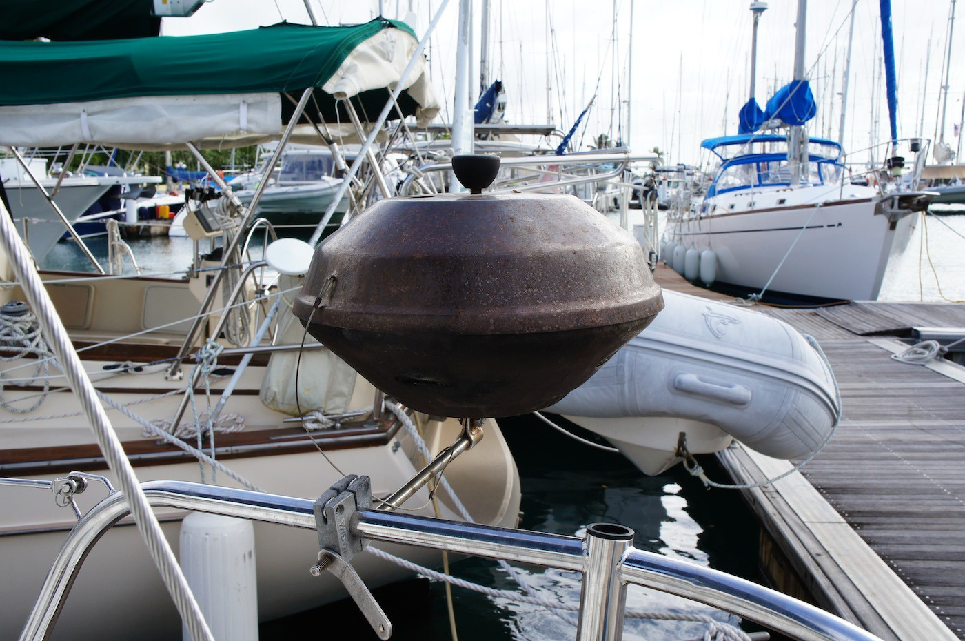

Dinghy and Outboard

- Always have your dinghy on a short line when docking or performing any close quarter maneuver.
- While underway ensure your dinghy is on a long line tied at the stern cleat.
- Make sure you are going at a slow speed(neutral) when moving your dinghy to a long line as it can be difficult to hold on to if not.
- Whomever is operating the dinghy should be over 18. Never operate the dinghy under the influence of alcohol.
- To start the engine, lower the engine, ensure fuel line is properly connected and pump fuel line bulb until hard. Make sure the kill-­‐cord is in place and that the gear lever is in neutral. Face the engine and pull the starter cord ensuring nobody is behind you. If after a few pulls and it still won’t start, pull out the choke and try again. When the engine has started push the choke back in.
- To stop the engine push in on the red button or pull the kill-­‐cord off.
- While underway the kill-­‐cord should be attached around the leg of the driver.
- To prevent dinghy theft use the lock provided and keep your kill cord with you while ashore.

- Do not speed while among other yachts and swimmers.
- At night you must carry and shine a torch at all times.
- It is suggested that you use the PFDs provided on your yacht while in the dinghy.
- A cable and lock are provided. It is your responsibility to ensure the dinghy does not get stolen. Please use lock at docks especially at night.
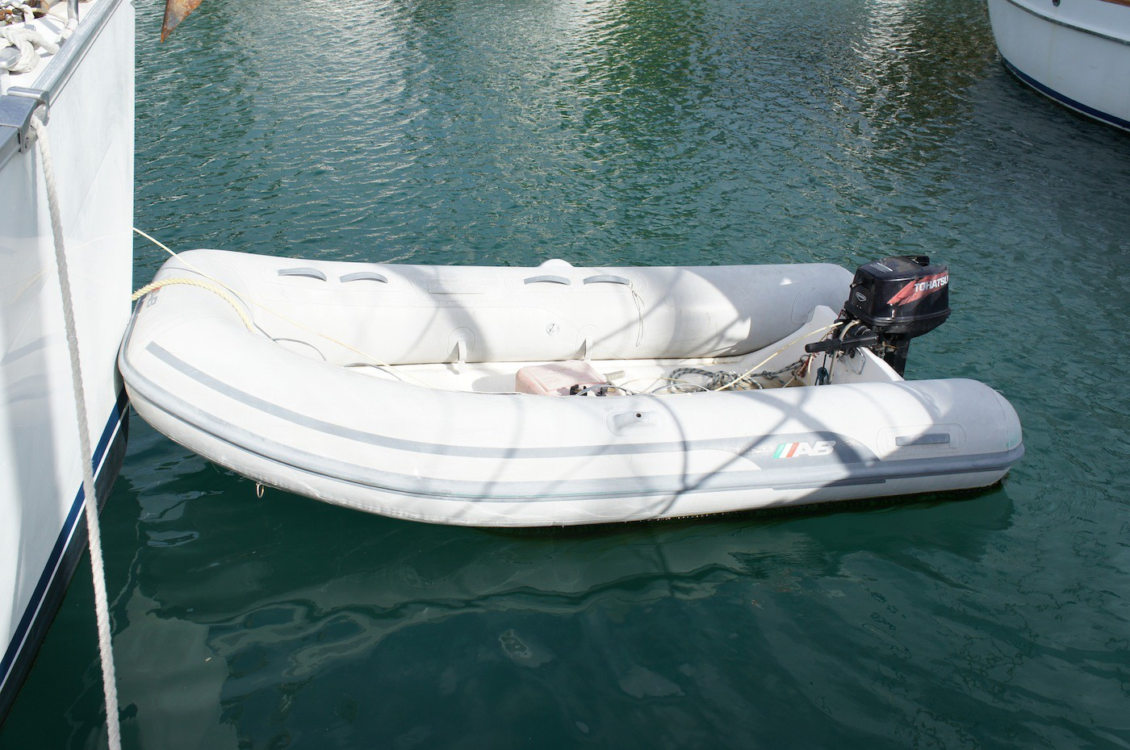

Maneuvers

Mooring
- Bring dinghy on to short line
- Consult cruising guide
- Prepare two mooring lines
- Each one bowlined to either bow cleats
- The person on the bow is in charge of the boat speed and direction using visual commands to the helm
- Motor to mooring from downwind only fast enough to ensure steerage is maintained
- When the person on the bow feels you have sufficient speed to coast to a stop at the mooring ball they instruct the helmsman to engage neutral. Try not to have to use reverse
- Mooring pendent is hooked using boat hook and brought onboard under the bow-­‐pulpit and secured to one of your mooring lines.
- That mooring line goes through the eye of the pendant and cleat hitched back on to the same cleat it is bowlined to
- You are now secure
- You can now pass your second line through the eye of the pendant and back to its respective cleat.
- Each line should be the same length and just long enough to avoid chaffing on the bow.

Leaving the mooring
- Again, ensure dinghy is on a short line
- Start engine
- Release one of your mooring lines
- When boat swings in the direction you wish to go release your second line
- Only start to motor away when helmsman can see the mooring ball

Anchoring
- 7 to 1 recommended scope
- Bring dinghy onto short line
- Prepare anchor
- Anchor locker door secure, safety line off, anchor tipped over bow
- Locate good drop spot (consult cruising guide)
- Allow person on bow to point you to target
- Allow the boat to come to a stop and drop anchor
- Initially drop half of expected rode
- Windlass pays out 2ft per second
- Boat will turn broadside to wind as she makes way to leeward
- When anchor catches the stern will kick downwind
- Pay out another 10 seconds of rode
- Continue sequence until you feel you have reached sufficient scope
- When boat has settled head to wind engage reverse in low rev’s
- Sight your on land transits
- If transits are still holding after one minute throttle up to medium rpm 1500
- After another minute increase rpm to 2000 rpm and wait another minute
- The boat should stay in the same place throughout this process
- The anchor is secure. Slide snubber hook over anchor’s chain forward of bow roller
- Secure other end to bow cleat
- Pay out a little more chain until snubber line is holding all the strain

Leaving Anchor
- Again, ensure dinghy is on a short line
- Rev engine in neutral to 1500rpm
- Remove snubber line
- Pull up anchor until you hear windlass start to strain or until chain no longer has any sag.
- Let the chain drop again under its weight pulling the boat forward
- Continue until all the chain is retrieved and anchor is free
- Communicate to the driver when the anchor is up
- Driver goes back in to neutral position and engages forward and motors away
- Secure anchor

Reefing Guidelines

The following is NESC’s suggested wind strengths for reefing

Reef 1 at 12-­‐15 knots

Reef 2 at 15+ knots

Use only partial jib after 20 knots

Troubleshooting
The following is a short list of common bareboat issues. For more complicated issues please contact NESC and let out engineers do the work.

Problem: Stove won’t light

Solution 1: Ensure solenoid switch is turned on Solution 2: Ensure propane tank valve is open

Problem: Toilet won’t prime

Solution: Pump in wet bowl setting very fast to bleed air

